Minutes of the meeting of Fringford Parish Council,
held on Monday 20th November 2023 at 7.45pm.

Present: Councillors: Ginny Hope (Chair), Les Harris, Phil Davids-Austin, Hayley Ryder, David McCullagh, Robert Gue

Also present: R. Damerell (Clerk) and 3 members of the public

- Apologies for absence
    - Apologies were received for Cllr MacKenzie.
- Requests for Dispensations and Declarations of interest, gifts and hospitality
    - No Dispensations were requested or Interests declared.
- Public participation
    - No questions were received from the public.
- Updates from County & District Councillors –
    - No update provided.
- To approve the Minutes of the last Parish Council Meeting.
    - The minutes were approved as a true record of the meeting.
- Finance
    - Budget – The Clerk has drawn up a first draft of the 2024/25 Parish Council budget. Cllrs Davids-Austin and Harris to review and amend the draft budget. This will then be brought to the December Parish Council meeting for review by the whole Council.
    - Financial Spreadsheet – The Councillors received the monthly Reconciliation.
    - Invoices to pay - The Invoices were reviewed and approved by the Council.
    - Co-op – Cllr McCullagh confirmed he is chasing the Co-Op to change the authorisation level to Clerk raise invoices on the online system and two Cllrs to authorise
    - Cllr Hope confirmed she had completed and sent her form to the Co-Op to be added to the mandate for the third time.

- Parish Matters
- Cherwell draft Local Plan Review 2040 (including village re-categorisation)
    - The draft Cherwell Local Plan is focussing on the housing needs for the whole of Cherwell up to 2040. The Plan is currently in consultation of which Fringford Parish Council is part of. Both Cllr Hope and Cllr McCullagh attended consultation events and were asked to provide feedback. Cllr Hope drafted a response which was agreed by Fringford Parish Councillors and was then sent on to Cherwell District Council. The feedback response will also be published in the Voice and for the benefit of those present at the meeting Cllr Hope read the response at the meeting (see appendix 1)
    - Fringford Village Plan – Cllr Hope proposed refreshing the Fringford Local Plan building on the 2016 Fringford Local Plan. Cllrs Hope and Ryder to review the questionnaire for residents. Cllr Hope proposed engaging Oxford Research to carry out the engagement with residents, including residents’ questionnaires and focus groups etc.
    - It was agreed for the timeframe to engage with the village and have the feedback would provisionally be the end of March 2024.
    - The Council agreed to budget £2,000 initially towards engaging Oxford Research.
    - Cllr Ryder stressed the importance to residents the Local Plan 2024 is about protecting the village and building resilience in the village not about trying to replicate a town in a village and to ensure there is a wide variety of residents who attend the focus groups to give a true and fair picture of representation from the whole village.
    - The Parish Council resolved to engage Research Oxford create a working group.
- HS2 Grant Applications for improvements to The Green
    - The Wall – Cllr McCullagh updated that The Wall is progressing well and that a space has been left to insert piece of stone in memorial for HM Queen Elizabeth II.
    - Pond Area – The quotes have been received and there is hope to present a draft design for the Village Sign for the review by the Council at the December meeting.
    - The area will be planted with bulbs and shrubs. The memorial bench will also be placed on site. Cllr Hope to approach the Shelswell Estate land agent for contribution of wildflowers and bulbs.
    - The Green / Car Park – The Highways project has been scheduled for the School Summer Holidays 2024. Oxfordshire County Council has absorbed the cancellation charge for the previous project with a maximum budget of £115,000. The money sits with Department of Transport so no interest able to be accrued. It has also been confirmed that any increase in cost through inflation would have to be met by the Parish Council. This equates to circa £10,000. Cllr McCullagh offered to raise this matter with Victoria Prentis MP.
    - The Voice – Cllr Hope to inform residents through the Voice that applications for parking on the Green will be suspended whilst the work is being carried out. The annual beer festival parking will be okay as this is in June prior to the works.
    - Funfair – The Clerk to inform the Funfair that due to the project it won’t be possible to have the funfair in Fringford in the summer of 2024 but would be invited back for 2025.

- New Vehicle Activated Sign for the village
    - Cllr Hope updated that the post has been erected on the Fringford Road. It is now waiting for the Highways officer and team to come and install the sign and fit it to the post
- Village Hall update including roof survey and bus stop survey
    - Thanks to Cllrs Gue and McCullagh for submitting the grant application to Cherwell District Council for £12,500 towards the £25,000 cost to repair the Village Hall roof.
    - Cllr Gue to raise with the Village Hall committee the possibility of installing further solar panels on the roof of the Village Hall.
    - Cllr Gue to approach a smaller building company to quote for the work to be done to the bus shelter.
- Play Area Inspection Report
    - Cllr McCullagh confirmed that all items raised in the RoSPA report have been repaired.
- Cherwell Parish Bulletin – Actions
    - No update to report

- Planning

Ref No: | Location | Proposal | PC Comments
23/02947/F | 11 Church Close, Fringford, Bicester, OX27 8DR | Single storey rear extension | Fringford Parish Council resolved to support the application following Cllr Ryder’s visit to neighbouring residents who provided positive feedback for the application.
23/02886/F | Land North Of A4421, Bicester Road, Fringford | Change of Use of land to a 4 pitch travellers caravan site and erection of stable building -  re-submission of 23/01368/F | Fringford Parish Council object to this application.  Cllr Hope raised a query directly to the Planning Team copying in the Leader of the Council and local councillor Barry Wood. The query was that despite Statutory consultees responding including Fringford Parish Council and neighbouring Parish Council’s, there was no response from Oxfordshire County Council Highways which was conspicuous, as they had previously objected in the previous application stating that the access was dangerous and hazardous.  The second application is also not very clear or well explained, though does suggest a new access point. The Parish Council objected stating this newly proposed access is still hazardous. Cllr Hope asked that if the delegated planning officer is minded to support the application then it is essential that the application is brought to the Planning Committee.

Decisions

Ref No: | Location | Proposal | Decision

Appeals

Ref No: | Location | Proposal | FPC Decision / Comments

- Correspondence Received / AOB
- None to report
- Items for next Agenda
- All items for the next agenda to be submitted to the Clerk by 8th December 2023.

- Date of next meeting:
- The date of the next meeting as 18th December 2023 at 7.45pm.

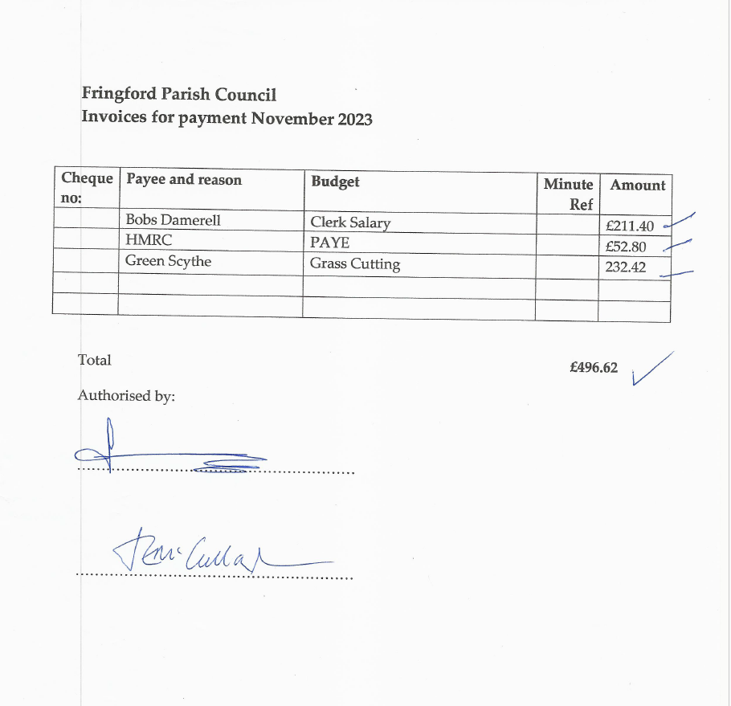

Appendix 1

Consultation Feedback from Fringford Parish Council on the Cherwell Local Plan 2040
draft consultation.

After Parish Councillors attended the consultation events and reading the draft LP2040
Cherwell Local Plan, we understand it is looking to re-categorise Fringford (and other
villages) as a smaller village. This means that we are unsustainable from a major planned
development point of view, but this does not appear to protect us from the kind of speculative developments that we have been constantly opposing and it also does not rule out having multiple ‘windfall’ developments in the same village.

Windfall development planning applications look like they will still be considered and
potentially allowed in unsustainable locations and the Parish Council would like to ask what
protection smaller village parish councils and smaller communities have against having to
continually oppose windfall developments that would be inappropriate for their smaller village category? The next iteration of the draft LP2040 Cherwell Local Plan will need to have clear and unambiguous policies to tighten up policies Villages 1 and Villages 2.

Ten houses would be a lot for a smaller village like Fringford. It appears that the concept of a windfall development is in direct contradiction of section 3.34 that talks about avoiding
unplanned development in rural areas and that developments to meet local community
needs would be more like one or two houses not nine or ten. Ten houses in a village with no public transport is at least a minimum 20 extra vehicles on rural roads and conflicts with
sustainable transport plans and lowering carbon emissions.

The draft LP2040 Cherwell Local Plan should also make it clear that there is no public
transport in smaller villages, such as Fringford, and no local shops or services and no safe
walking or cycling routes to Bicester, to avoid speculative planning applications being
submitted. These consume resources at all levels including residents and parish councils
spending money on planning consultants to object and oppose appeals because the
developers writing the planning application assume that you can commute into Bicester via
green, sustainable transport routes. This is not the case. The key points of no shops and
services or safe, green, and sustainable travel appears to be missing from the smaller
villages’ definition in the draft plan.

The draft LP2040 Cherwell Local Plan states that the rural areas will need to be allocated
500 homes. Our feedback on this is that smaller villages should be looked at on a case-by-
case basis to ensure that future development is about the right properties in the right places
and not about arbitrary allocations being made on a number’s basis. Dorchester Living
(developers), propose some of the 500 homes could go on brownfield land at Heyford Park
instead of the villages. Fringford Parish Council supports this and urges Cherwell District
Council to assess the capacity of the brownfield land at Heyford Park to take more
development as it is a sustainable location with shops, services, and public transport.

The draft rural areas strategy states that it will “protect the character, appearance, heritage
and identity of our villages.” Fringford Parish Council strongly supports this statement and
would not support an allocation of the 500 houses that was outside the built-up limit of the
village, or that would negatively impact on the rural in character nature of the village street
scene and listed buildings or that would negatively impact on the surrounding open
countryside.

Fringford is a historic village, and this is reflected in parts of the village street scenes and its
rural in character nature. The village has had 4 in-fill new build properties, and a further 4- 2 bedroom property has planning permission. The opportunities for future in-fill planning
applications are few because of the nature of the existing built environment and where
spaces occur for a gap or a gateway to a field, for example, this does not mean it should be
filled with houses. Gaps in the built environment are a key part of the village’s historic street
scene and rural in character nature. To be supported by the Fringford Parish Council, any
future planning applications for in-fill should meet the in-character design, meet the needs of our community, such as a small number of affordable homes for local people in locations that would not have a negative impact on listed buildings and the historic street scenes, as we wish to enhance the environmental and heritage assets.

Fringford Parish Profile

We note that in the Fringford Parish profile contained within the draft LP2040 Cherwell Local Plan it states that two sites LPR-A-078 Land at Hall Farm and LPR-A-171 Land to the west of Fringford are “promoted” for use for housing. Fringford Parish Council would not support planning applications on either of these sites and request that they are removed from the subsequent versions of the draft local plan because;

LPR-A-078 Land at Hall Farm is an agricultural field backing on to open countryside and
adjacent to two Grade II listed buildings, namely Hall Farm and The Forge. The frontage of
this field and opening on to Main Street forms a key part of the of the village’s historic street scene and rural in character nature. It would detrimentally impact on the character and appearance of the area and would be out of keeping with the established built form of
Fringford.

This village profile states, “the listed buildings {in the village} are considered to be sensitivity
in contributing towards the historic character of the village.” In addition, the profile also
shows there are no services except for a part-time pub and a primary school.

LPR-A-171 Land to the west of Fringford is in the open countryside and beyond the built-up
limits of the village. This same piece of land has already had a planning application for 10
houses refused by Cherwell District Council in September 2022 (21/02553/OUT Land
adjoining The Cottage, The Green, Fringford) “because it would detrimentally impact on the
character and appearance of the area and would be out of keeping with the established built form of Fringford.” See notice of decisions - reasons for refusal.

We hope that our feedback will be considered in the next version of the draft LP2040
Cherwell Local Plan.

Ginny Hope

Chair

On behalf of Fringford Parish Council

02 November 2023 and updated 06/November 2023

